Yucel 12V Batteries

General Purpose, 12VDC Lead-Acid Batteries

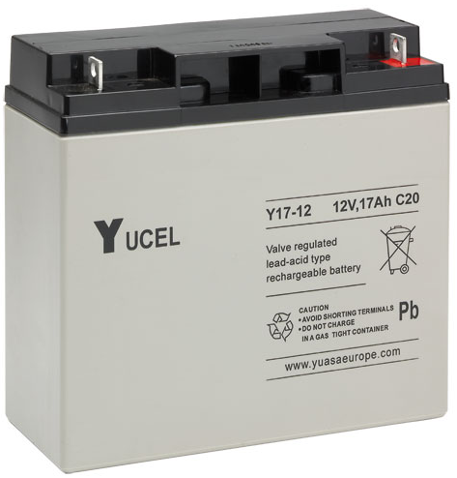
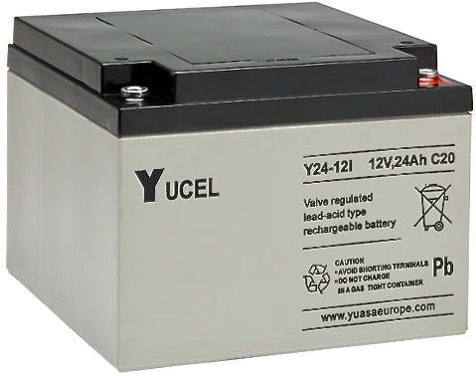

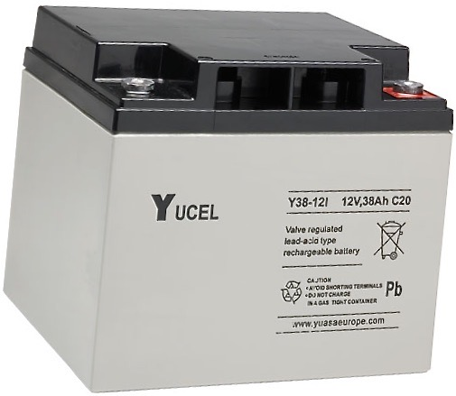

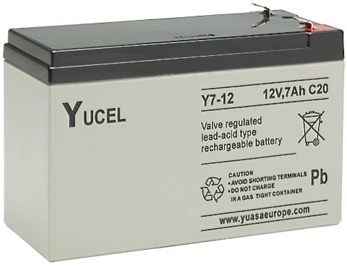

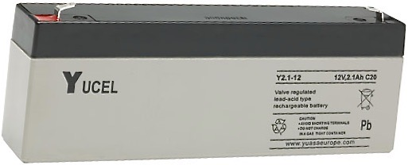

- EUROBAT Classification

- Superior Life Lead-Calcium Grids

- General Purpose VRLA batteries
- Operate in any configuration

This family of Yucel 12VDC rechargeable batteries from the renowned Yuasa Company, has been selected by Dycon as it complements the advanced features of Dycon's extensive range of power supplies, features that include low voltage cut-off, to avoid battery deep discharge and, on the 'Intelligent' range, full battery impedance checks to give prior warning of impending battery problems. The range provides reliable standby power from 2.1Ah, 7Ah, 17Ah, 24Ah to 38Ah for all intruder, access control, fire, CCTV and building management systems. The 24Ah and 38Ah versions are ideal for supplying the higher power needed for larger access control and EN50131 Grade 4 intruder systems. For 24VDC systems and usage, connect 2 x 12VDC versions together but please remember that the total current output is not twice that of a single battery but will be reduced by 50%. To save time and having to source from different suppliers, Dycon can package and deliver any of its power supplies complete with a suitable battery from this range. All you need to do is select your power supply, decide which battery suits your needs and just contact Dycon Sales.

General Purpose Standby Batteries
12 VDC - 2.1Ah, 7Ah, 17Ah, 24Ah and 38Ah Lead Acid Batteries

Technical Specifications

SPECIFICATION | DYCON PART NUMBER
 | BAT004 | BAT003 | BAT005 | BAT006 | BAT007
Nominal Voltage | 12VDC | 12VDC | 12VDC | 12VDC | 12VDC
Amperage (Ah) | 2.10 | 7.00 | 17.00 | 24.00 | 38.00
20 Hour rate capacity to 10.5V at 25° C | 2.10 | 7.00 | 17.00 | 24.00 | 38.00
10 Hour rate capacity to 10.8V at 25° C | 1.90 | 6.40 | 15.70 | 22.00 | 35.80
Length (mm) | 178 | 151 | 181.5 | 166 | 197
Width (mm) | 34 | 65 | 77 | 175 | 165
Height over terminals (mm) | 64 | 94.5 | 167.5 | 125 | 170
Weight (kg) | 0.82 | 2.45 | 5.70 | 9.00 | 14.20
Terminal Type | Faston 4.75 | Faston 4.75 | M5 | M5 | M5

ALL VERSIONS
Operating temperature Discharge | -20° to +60°C
Operating temperature Discharge | -20° to +60°C
Storage temperature, fully charged | -20° to +60°C
Capacity loss % per month in storage at 20°C | 3%
Case material | ABS (UL94:HB)
Charge voltage at 20°C | 13.65V
Design life at 20°C | 3 to 5 years
3rd Party Certifications | UL™, BSI™, VDS™
Installation Information | Batteries can be fitted in any configuration except permanently inverted.
Recycling Information | These batteries must be recycled at the end of life in accordance with local and national laws and regulations.

Dycon Power Solutions Ltd
Unit A, Cwm Cynon Business Park, Mountain Ash, CF45 4ER, United Kingdom.
For more information about the Dycon products:
www.dyconpower.com
Or to discuss your specific needs:
+44 (0)1443 471 900 Batteries data sheet 25032020 V3

Dycon leads the security and associated power supply markets, with UK design and manufacture of advanced power products, engineered to provide high quality, cost-effective solutions to meet current regulations and the specific needs of system integrators and end-users.

