
Dycon Accessories

Universal 12VDC – 27.6VDC Output Splitters

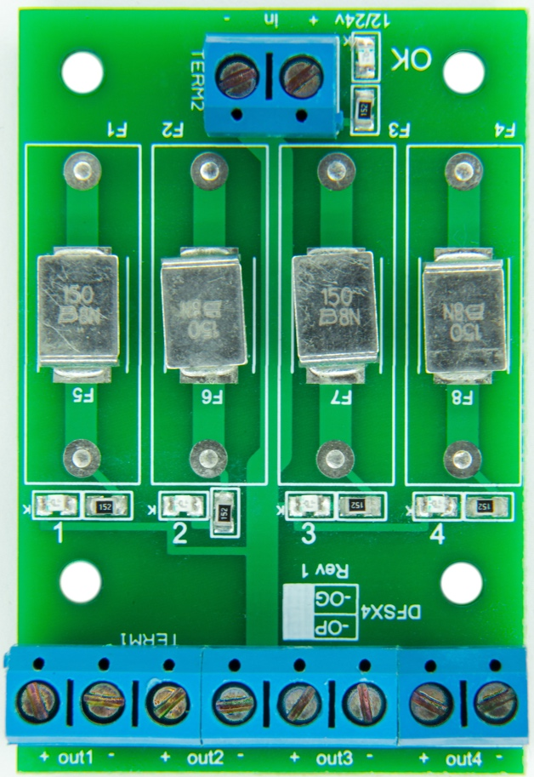

DFX4-0P 4-way, self-resetting, electronically-fused output splitter

Dycon output splitters enable a single power supply unit to drive several different devices at the same time. The range consists of three different types of splitters that cover most system requirements. They take the DC power output from any Dycon, or most other make, 12VDC or 24VDC power supplies, and distribute it into four or eight protected outputs to drive peripheral systems components. The full range consists of an electronically-fused 4-way, conventional glass-fused 4 and 8-way and a glass-fused unit with4 x BNC loop-through video outputs for powering over-the-coax CCTV cameras each has two additional 1A conventional wired outputs. The DFXS4-0P, a four-output version (shown above), is protected by self-resetting, electronic fuses, each with a maximum rated output of 1.5A. These units have green LEDs to indicated when an output is powering normally.
Part No. DFXS4-0P (4-way, Electronically-fused, Output Splitter)
Voltage Input | 12VDC to 27.6VDC
Electronic Output Fuses | 4 x 1.5A
Operating Temperature Range * | -25˚C to +40˚C
Humidity | 95% non-condensing
PCB size (h x w x d) | 60 x 40 x 15mm

* The PTC electronic fuse ratings increase/decrease depending on temperature, contact Dycon Power Solutions for more information
Dycon leads the security and associated power supply markets, with UK design and manufacture of advanced power products; to provide high quality, cost-effective solutions to meet current regulons and the specific needs of system integrators and end-users.
Designed and in the U
Glass-fused 12VDC-27.6VDC Output Splitters

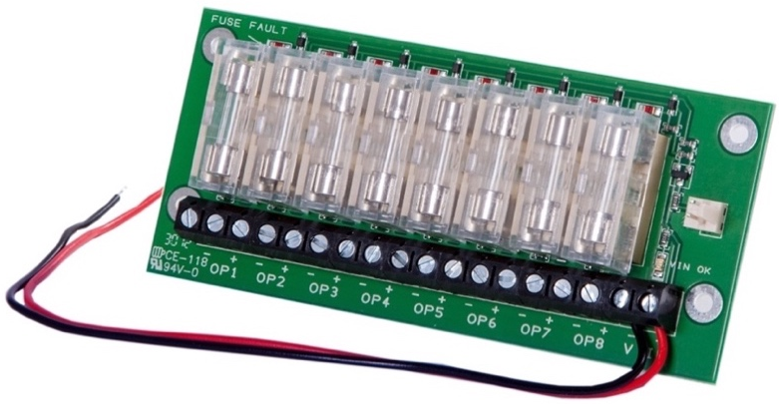

D15X8 8-way, glass fused, output splitter

These two useful splitters are protected by individual glass fuses, which are included with each unit. They feature individual, surface-mount red LEDs showing whenever a particular fuse has blown. The fuse values can be changed to suit the load required at each point up to a maximum not exceeding the rated power output of the entire power supply. Outputs can also be wired together to create a higher rated output provided the fuse is uprated to match, for instance 2 x outputs could be linked together provide a 2A single output, providing a 2A fuse is fitted to both outputs.
Glass-fused Output Splitters | D15X8-500mA | D15X8-1A
Voltage Input | 12VDC to 27.6VDC | 12VDC to 27.6VDC
Output fuses (supplied) | 8 x 500mA | D15X8 - 8 x 1A
Fuse Type | Glass 5 x 20mm | Glass 5 x 20mm
Operating Temperature Range | -25˚C to +65˚C | -25˚C to +65˚C
Humidity | 95% non-condensing | 95% non-condensing
PCB size (h x w x d) | 108 x 49 x 15mm | 108 x 49 x 15mm

Dycon Power Solutions Ltd
Unit A, Cwm Cynon Business Park, Mountain Ash
CF45 4ER, United Kingdom.
For more information about the Dycon products:
website: www.dyconpower.com
email: sales@dyconpower.com
Or to discuss your specific needs:
+44 (0)1443 471 900

Dycon leads the security and associated power supply markets, with UK design and manufacture of advanced power products; engineered to provide high quality, cost-effective solutions to meet current regulations and the specific needs of system integrators and end-users.
Designed and manufactured in the UK

Splitters data sheet 11032026 V12



